OSI LAYER

- Draw a diagram of the OSI 7-layer model and label each layer with its correct name and a real-world example of a device or protocol that operates at that layer (e.g., Switch at Data Link, HTTP at Application).
Answer
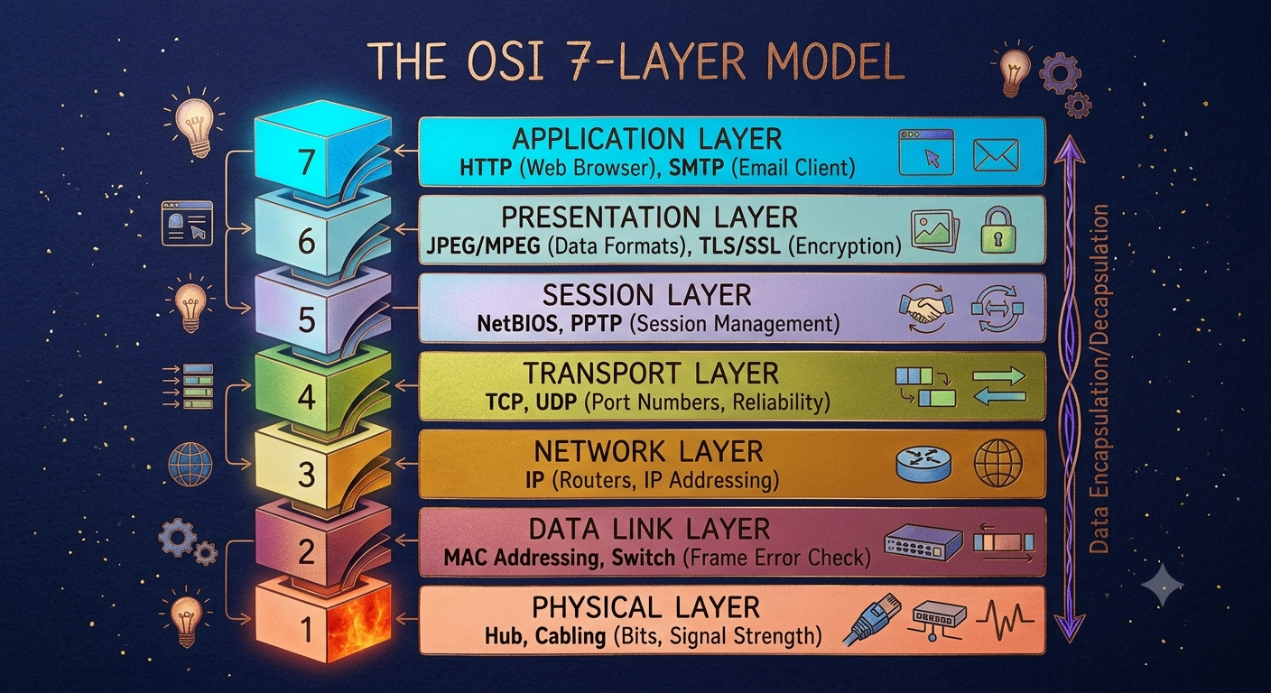
- Match the following networking scenarios to the correct OSI layer: a) Encrypting data before sending, b) Routing packets across networks, c) Converting data to electrical signals, d) Opening a web page in your browser, e) Detecting and correcting errors in frames. Write your answers as 'Scenario: Layer Name (Layer Number)'.
Answer
- Encrypting data before sending: Presentation layer (Layer 6)
b) Routing packets across networks: Network layer (Layer 3)
c) Converting data to electrical signals: Physical layer (Layer 1)
d) Opening a web page in your browser: Application layer (Layer 7)
e) Detecting and correcting errors in frames: Data Link layer (Layer 2)
- Pick any app you use daily (like WhatsApp, Instagram, or Zomato) and describe how at least three different OSI layers are involved when you send or receive data in that app.
Answer
Using Instagram as the example, here’s how three OSI layers work when you post or view a photo:
- Application layer (Layer 7) – The Instagram app formats your post (image, caption, hashtags) and uses HTTPS to communicate with Instagram’s servers via APIs for uploading and fetching feeds.
- Transport layer (Layer 4) – TCP ensures reliable, in-order delivery of your photo and feed data between your phone and Instagram’s servers, handling segmentation, ports, and retransmission if packets are lost.
- Network & Data Link layers (Layers 3 & 2) – IP (Layer 3) routes packets across the internet to Instagram’s data centers using logical IP addresses, while Wi-Fi or mobile data (Layer 2) moves frames between your device and the local access point using MAC addresses and error checking.
These layers together make your photo upload and feed loading work reliably over the internet.

- Given this scenario: You are unable to access a website, but you can successfully ping its IP address. Identify which OSI layer(s) might be causing the problem and explain your reasoning.
Answer
Most likely layers involved: Application layer (Layer 7) and possibly Transport layer (Layer 4), with DNS (also Layer 7) as a common culprit.
- DNS / Application layer (Layer 7) – If you can ping the IP but not access the site by name, the domain name may not be resolving correctly (wrong/failed DNS), which is an Application-layer issue.
- HTTP/HTTPS / Application layer (Layer 7) – The web server might be down, misconfigured, or blocking your requests (e.g., firewall rules, wrong port, SSL issues), so IP connectivity works but the web service does not.
- Transport layer (Layer 4) – A firewall or server rule could be blocking TCP port 80/443 while still allowing ICMP (ping), so packets reach the host but the HTTP/HTTPS connection is refused or dropped.
In short: ping success shows Layers 1–3 are fine; the problem is almost certainly at Layer 4 or Layer 7 (DNS, HTTP/HTTPS, or port blocking).

